Weekly Accomplishments

* Met together and discussed a few plans of action
* Created two for pages: project

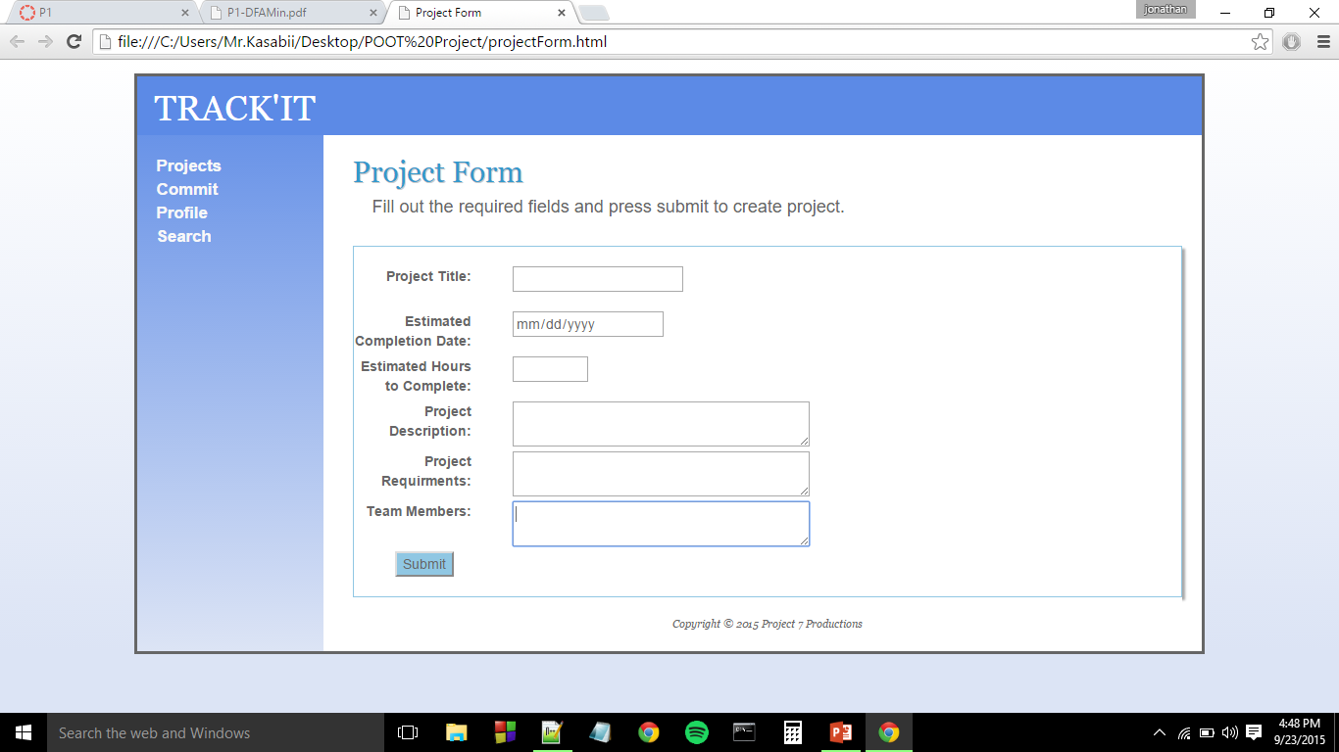

* Version 2

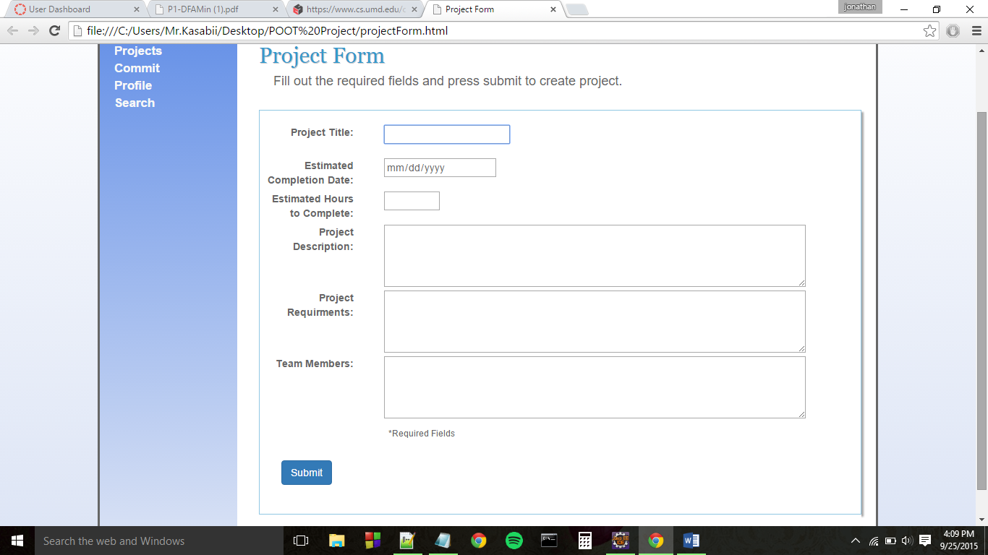

* Commit form

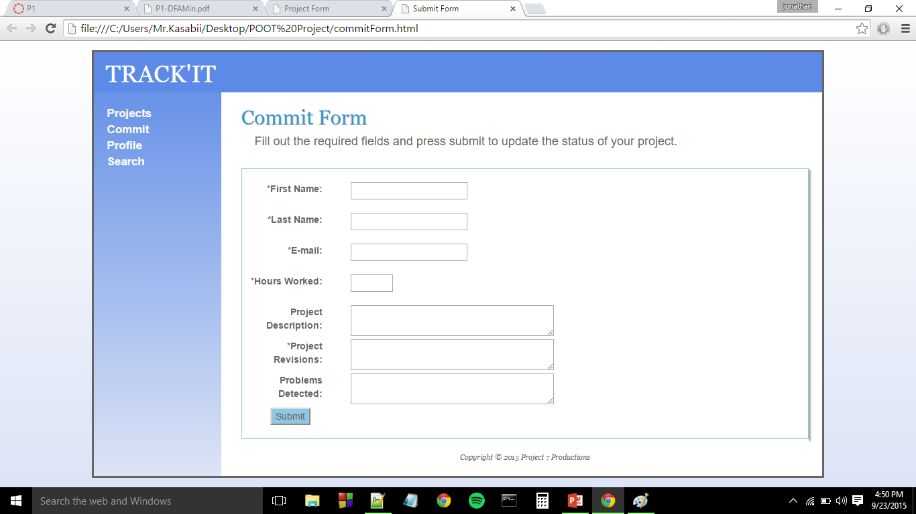

* Version 2

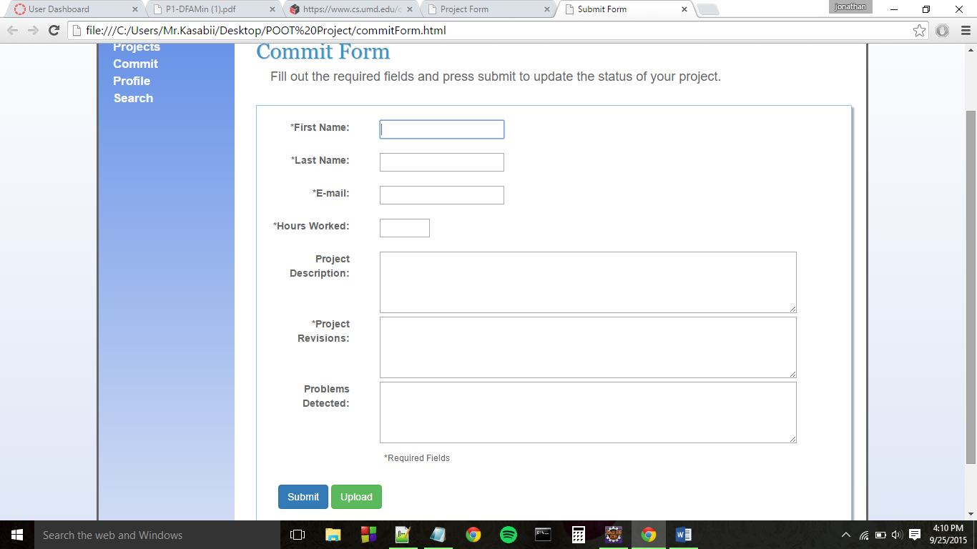

* Looked into making an interactive front page with bootstrap and html5
* Updated the home page

